


SPECIFICATION

Name：DC Shunt Resistor
Model：FL-15
Specification：100A/75mV
Accuracy Class:0.25%
Material of Blade:Manganese cooper
Material of both side studs:Brass

1. The standard of application：
a. National Standard:
National Standard of the People's Republic of China: GB/T7676-1998 "Direct acting indicating analogue electrical measuring instruments and their accessories".
Professional Standard of the People's Republic of China: JB/T9288-1999 "External Shunt"
b. Safety standards:
IEC 61010-1:1990 " Safety Requirements For Electrical Equipment For Measurement, Control And Laboratory Use - Part 1: General requirements"

2. The treatment of surface：
Ssandblasting the surface of the shunt；

3. The method of measurement：
Zero balanced resistance bridge method.

4. The parameter of shunt(for example)：
model | nominal value | error value | level | rated current | rated secondary voltage
100A/75mV | 0.75×10-3Ω | ±1.875×10-6Ω | 0.25 | 100A | 75mV

5. The influence of temperatures:
The ambient temperature changes by 10 °C, and the output signal of the shunt does not exceed 50% error of the accuracy;

6. Appearance：
There is a mark on the nameplate or implement;
A. The model of shunt;
B. Manufacturer (trademark);
C. Accuracy class;
D. rated primary current;
E. rated secondary voltage;

7. Overload capacity:
a. Continuous overload:
Withstand 120% of rated current 2H, no more than allowable error after cooling.
b. Transient overload:
When the shunt is subjected to 3 times of rated current shock 5S or 10 times of rated current shock 0.5s will not damage. After cooling to the reference temperature, the allowable error is not exceeded.

8. The influence of Thermoelectric potential：
When 80% of the rated current passes through the shunt, the resistance deviation caused by the change of thermoelectric potential, shall not exceed 50% of the grade

9. The load under the heat:
Temperature stability tends to change, the rated current 50A the following does not exceed 80 ℃; rated current 50A or more does not exceed 120 ℃.
10. The drawing of dimension：
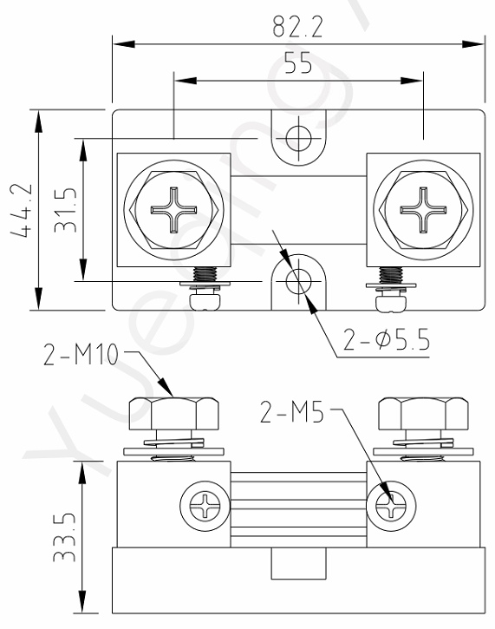

11.Electrical performance and test specification:

- Resistance value: The resistance value measured by the shunt in the above environment is compared with its nominal resistance value, and the error must be within the allowable error range。
b. Rated voltage: Rated voltage refers to the rated DC continuous operating voltage of the shunt, which can be calculated by the following formula:
U=IxR I: rated current (A) R: nominal resistance (Ω) U: rated voltage (V)
c. Rated power: The rated power of the shunt is usually referred to as the maximum power that the shunt can continuously use when the ambient temperature is lower than 25 ° C. When the ambient temperature is higher than 25 ° C, the rated power is determined by the power reduction curve shown in the figure below.
rated power consumption
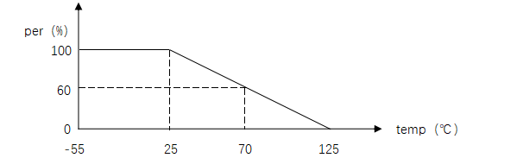
d. Mechanical impact: Mechanical impact test is conducted at room temperature in accordance with GB/T31467.3. Resistance values before and after test are measured. Resistance changes are in line with grade value, The shunt has no damage in appearance.
e. Random vibration: mechanical impact test was carried out at room temperature in accordance with GB/T31467.3. Resistance values were measured before and after the test. Resistance changes were in line with the grade index, and the appearance of the shunt was not damaged.
f. High temperature storage: Test in high temperature incubator for 1000h, 80℃, without load, test resistance Ri every 100h, a total of 11 tests, resistance value change in line with the grade index.
g. Low temperature storage: test 250h, -40℃, without load, in the test box, test resistance Ri every 50h, a total of 6 tests, resistance change in line with the grade index, no damage to the shunt appearance
h. Humidity resistance: test T=24h/ cycle (25℃~65℃, 90% relative humidity, no load, Step7a/7b does not need), repeat 16 cycles; In the test box, the resistance Ri was tested once every two cycles, a total of 9 times, and the resistance value change was in line with the grade index.
i. Rapid temperature change: Put the shunt into the thermostat at a specified temperature, and the conversion time between taking the shunt out of one thermostat and putting it into another thermostat is 2-3min. Cycle 5 times in the following order.

sequence | temperature | exposure duration
1 | -40±3℃ | 30min
2 | 80±3℃ | 30min

Then put the diverter in the normal temperature and normal humidity state to recover for at least 1h, and then measure the resistance value of the diverter. The change of resistance value conforms to the grade index
j. Surface temperature rise: At room temperature, the shunt passes the rated current. 4h later, when the shunt reaches thermal stability, measure the surface temperature of the shunt (2 copper ends, weld joint, manganese copper rods, 2 test points for each), take the maximum temperature of each test point, and calculate the temperature rise. The temperature rise shall not exceed 80℃
k. Thermoelectric potential: when 80% of the rated current passes through the shunt, the resistance value generated by the thermoelectric potential changes, not exceeding 50% of the grade index;

